**student_faculty Database :**

CREATE DATABASE student_faculty;

USE student_faculty;

CREATE TABLE student(

snum INT,

sname VARCHAR(10),

major VARCHAR(2),

lvl VARCHAR(2),

age INT, primary key(snum));

CREATE TABLE faculty(

fid INT,fname VARCHAR(20),

deptid INT,

PRIMARY KEY(fid));

CREATE TABLE class(

cname VARCHAR(20),

metts_at TIMESTAMP,

room VARCHAR(10),

fid INT,

PRIMARY KEY(cname),

FOREIGN KEY(fid) REFERENCES faculty(fid));

CREATE TABLE enrolled(

snum INT,

cname VARCHAR(20),

PRIMARY KEY(snum,cname),

FOREIGN KEY(snum) REFERENCES student(snum),

FOREIGN KEY(cname) REFERENCES class(cname));

INSERT INTO STUDENT VALUES(1, 'jhon', 'CS', 'Sr', 19);

INSERT INTO STUDENT VALUES(2, 'Smith', 'CS', 'Jr', 20);

INSERT INTO STUDENT VALUES(3 , 'Jacob', 'CV', 'Sr', 20);

INSERT INTO STUDENT VALUES(4, 'Tom ', 'CS', 'Jr', 20);

INSERT INTO STUDENT VALUES(5, 'Rahul', 'CS', 'Jr', 20);

INSERT INTO STUDENT VALUES(6, 'Rita', 'CS', 'Sr', 21);

INSERT INTO FACULTY VALUES(11, 'Harish', 1000);

INSERT INTO FACULTY VALUES(12, 'MV', 1000);

INSERT INTO FACULTY VALUES(13 , 'Mira', 1001);

INSERT INTO FACULTY VALUES(14, 'Shiva', 1002);

INSERT INTO FACULTY VALUES(15, 'Nupur', 1000);

insert into class values('class1', '12/11/15 10:15:16', 'R1', 14);

insert into class values('class10', '12/11/15 10:15:16', 'R128', 14);

insert into class values('class2', '12/11/15 10:15:20', 'R2', 12);

insert into class values('class3', '12/11/15 10:15:25', 'R3', 11);

insert into class values('class4', '12/11/15 20:15:20', 'R4', 14);

insert into class values('class5', '12/11/15 20:15:20', 'R3', 15);

insert into class values('class6', '12/11/15 13:20:20', 'R2', 14);

insert into class values('class7', '12/11/15 10:10:10', 'R3', 14);

insert into enrolled values(1, 'class1');

insert into enrolled values(2, 'class1');

insert into enrolled values(3, 'class3');

insert into enrolled values(4, 'class3');

insert into enrolled values(5, 'class4');

insert into enrolled values(1, 'class5');

insert into enrolled values(2, 'class5');

insert into enrolled values(3, 'class5');

insert into enrolled values(4, 'class5');

insert into enrolled values(5, 'class5');

**Student table**

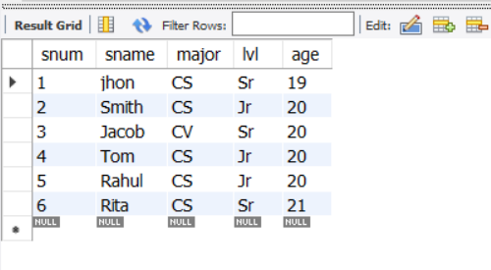

**Faculty table**

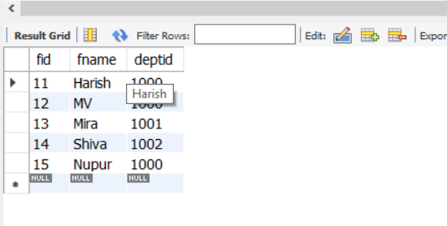

**Class table**

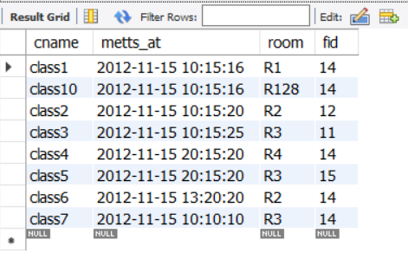

**Enrolled table**

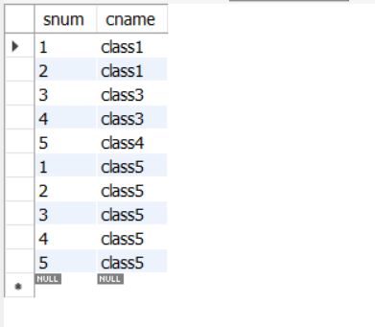

**-- Query 1**

SELECT DISTINCT S.Sname

FROM Student S, Class C, Enrolled E, Faculty F

WHERE S.snum = E.snum AND E.cname = C.cname AND C.fid = F.fid AND

F.fname = 'Harish' AND S.lvl = 'Jr';

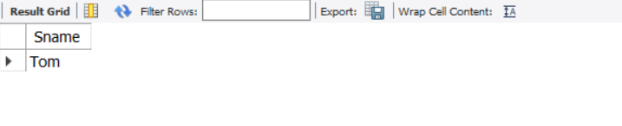

**-- Query 2**

SELECT DISTINCT cname

FROM class

WHERE room='R128'

OR

cname IN (SELECT e.cname FROM enrolled e GROUP BY e.cname HAVING COUNT(*)>=5);

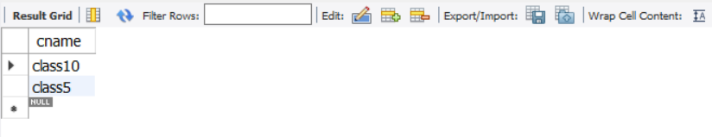

**-- Query 3**

SELECT DISTINCT S.sname

FROM Student S

WHERE S.snum IN (SELECT E1.snum

FROM Enrolled E1, Enrolled E2, Class C1, Class C2

WHERE E1.snum = E2.snum AND E1.cname <> E2.cname

AND E1.cname = C1.cname

AND E2.cname = C2.cname AND C1.metts_at = C2.metts_at);

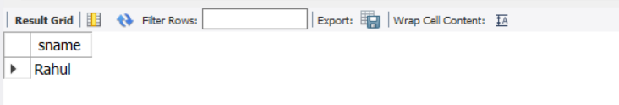

**-- Query 4**

SELECT f.fname,f.fid

FROM faculty f

WHERE f.fid in ( SELECT fid FROM class

GROUP BY fid HAVING COUNT(*)=(SELECT COUNT(DISTINCT room) FROM class) );

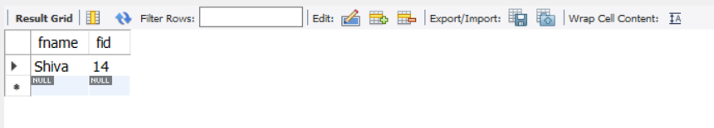

**-- Query 5**

SELECT DISTINCT F.fname

FROM Faculty F

WHERE 5 > (SELECT COUNT(E.snum)

FROM Class C, Enrolled E

WHERE C.cname = E.cname

AND C.fid = F.fid);

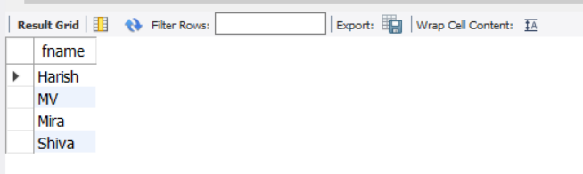

**-- Query 6**

SELECT DISTINCT S.sname

FROM Student S

WHERE S.snum NOT IN (SELECT E.snum

FROM Enrolled E );

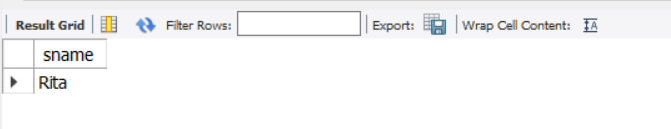

**-- Query 7**

SELECT S.age, S.lvl

FROM STUDENT S

GROUP BY S.age, S.lvl

HAVING S.lvl IN(SELECT S1.lvl

FROM STUDENT S1

WHERE S1.age=S.age

GROUP BY S1.age, S1.lvl

HAVING COUNT(*) >= ALL (SELECT COUNT(*)

FROM STUDENT S2

WHERE S1.age=S2.age

GROUP BY S2.lvl, S2.age))

ORDER BY S.age;

